LRCH System solution
  - Zachariah Elhayek, Ethen Chen, Can Saruhan, Ray Oviasuyi

Table of Contents
Introduction 3
Mission Statement 4
Data Flow Diagram 5
Functional/Non-Functional Requirements 6
Functional Requirements 6
Non-Functional Requirements 6
3NF 7
Entity Relationship Diagram 8
Data Dictionary 9

Introduction
To fulfill the needs of the Lake Ridge Community Hospital, we have developed a new system to meet the hospital’s needs. This new application will allow for: medical staff to be able to record lab results for patients, digitize treatment subscriptions, removal of the batch-oriented system to allow for immediate recording and retrieval of information, and allow for scalability for future development. Along with the above additions/improvements, the system will be packaged in a web-application to allow for use on any device.

Mission Statement
The purpose of the LRCH project is to provide greater efficiency to the operations of the hospital through a centralized system capable of managing the day-to-day requirements of the LRCH staff in order to provide free and high-quality health care to the community of Oshawa.

Data Flow Diagram

Functional/Non-Functional Requirements

Functional Requirements
- Record lab results
- Record prescriptions
- Accumulate revenue by cost Centre
- Must be flexible/scalable to meet the need of a changing environment
- Room-Utilization Dashboard

Non-Functional Requirements

Operational Requirements
- Online transaction processing
- Minimum system requirements
- Recommended system requirements
Performance Requirements
- Within 3 – 4 seconds retrieval/adding of datamor
Security Requirements
- Must check the credentials of user login to verify what type of user they are
Cultural / Political
- What language is the system in?

- Handle 15k or more active patient data
- Must usable offline in the case of an internet outage

3NF
Admissions (VisitID, PatientNumber, LocationID, DateAdmitted, DischargeDate)
Patient (PatientNumber, PatientFirstName, PatientLastName, FinancialStatus, PatientAddress, City, Prov, PC, Telephone, Sex, HCN)
Physician (PhysicianId, PhysicianFirstName, PhysicianLastName, Telephone, Specialty)
Cost Center (CostCenterId, CostCenterName)
Location (LocationID, Room#, BedId, Extension, Type)
Items (ItemID, CostCenterId, Description, ItemPrice, ItemQtyOnHand)
ChargedItems (ChargedItemId, ItemID, VisitID, ChargeDate, TotalCharge)
PatientResults (PatientResults, ChargedItemID, Results)

Entity Relationship Diagram
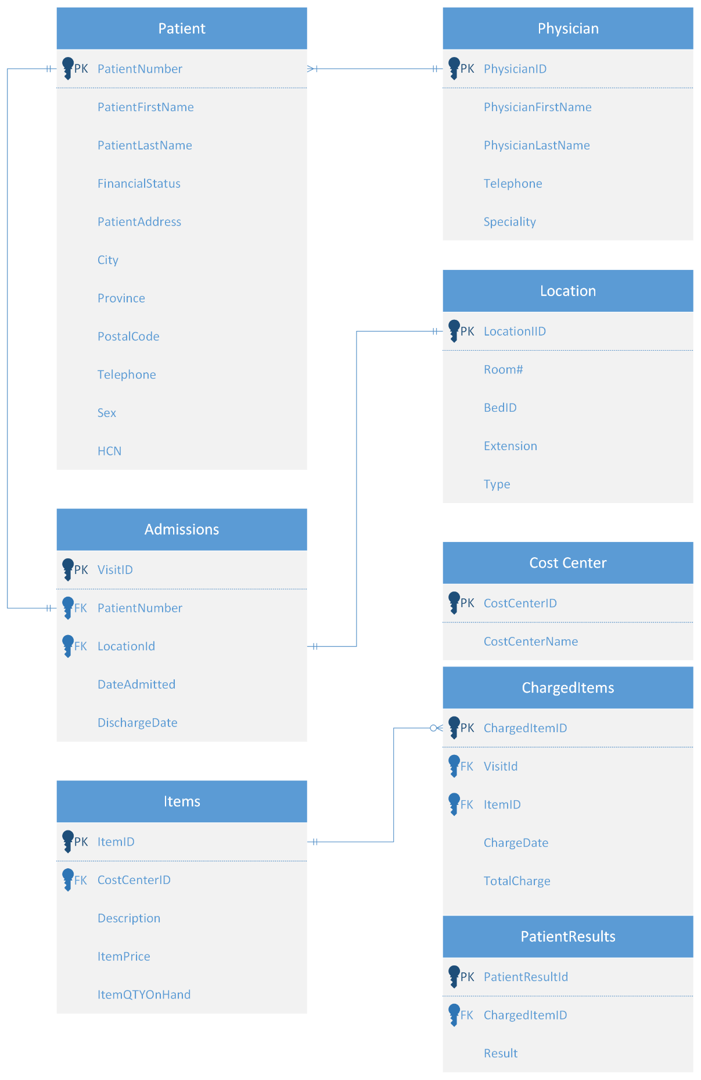

Data Dictionary
Table | Attribute | Type | Format | PK/FK | Referencing  Table
Admissions | VisitID | Int |  | PK
 | PatientNumber | Int |  | FK | Patient
 | LocationID | Int |  | FK | Location
 | DateAdmitted | Date | YYYY-MM-DD
 | DischargeDate
Patient | PatientNumber | Int |  | PK
 | PatientFirstName | Varchar
 | PatientLastName | Varchar
 | Telephone | Char | x xxx-xxx-xxxx
 | FinancialStaus | varchar
 | PatientAddress | varchar
 | City | Varchar
 | PC | Char | A1A-1A1
 | Sex | Char
 | HCN | Char | xxxx-xxx-xxx-AA
Physician | PhysicianID | Int |  | PK
 | PhysicianFirstName | Varchar
 | PhysicianLastName | Varchar
 | Telephone | Char | x xxx-xxx-xxxx
 | Speciality | Varchar
Cost Center | CostCenterID | Int |  | PK
 | CostCenterName | Varchar
Location | LocatoinID | Int |  | PK
 | Room# | Int
 | BedId | Int
 | Extension | Int | xxx
 | Type | Varchar
Items | ItemID | Int |  | PK
 | ConstCenterID | int |  | FK | Const Center
 | Description | Varchar
 | ItemPrice | Money
 | ItemQTYOnHand | Int
Charged Items | ChargedItemID | Int |  | PK
 | ItemID | Int |  | FK | Items
 | VisitID | Int |  | FK | Admissions
 | ChargeDate | Date
 | TotalCharge | Money
Patient Results | PatientResults | Varchar |  | PK
 | ChargedItemID | Int |  | FK | Charged Items
 | Results | Varchar

